Basic SQL Questions

1) Given two tables: departments (id, name), workers (id, name, department_id)

Create a query to find all departments where nobody works

* 1. Find two alternative ways to write this query
  2. Which option will be better from the performance point of view and why

Answer:

a)

i) SELECT d.name FROM Department d

LEFT JOIN Worker w ON w.department_id = d.id

WHERE w.id IS NULL

ii) SELECT d.name FROM Department d

WHERE NOT EXISTS (SELECT department_id FROM Worker WHERE department_id=d.id)

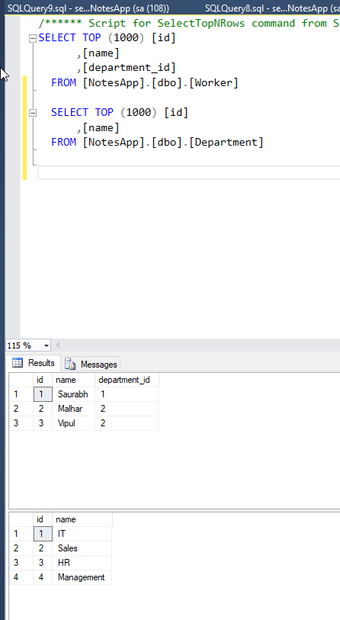 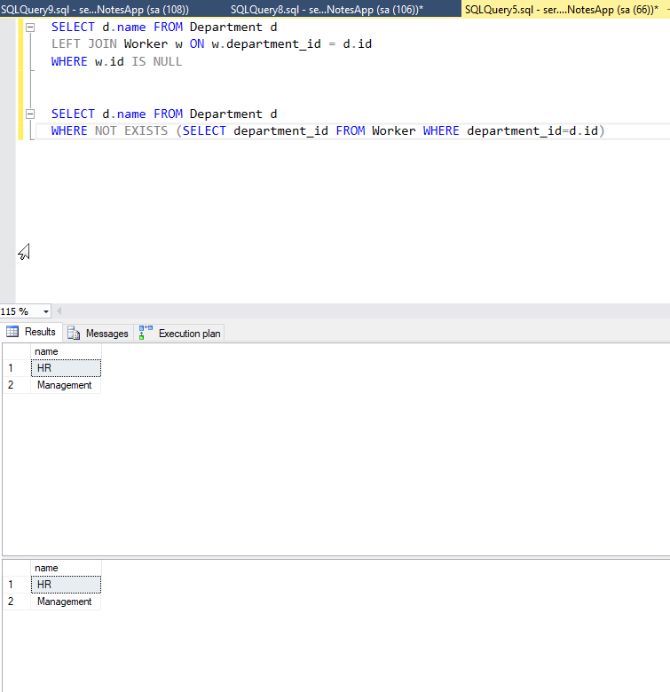

b) Option 2 will be better for the performance point of view.

Reason: A Left Join will give one row per worker. You'd need DISTINCT. Which compromises the plan compared with NOT EXISTS.

2) Given a following query propose the correct index structure to improve the query performance:

Select top 5 *  
from t  
where f0=0  
order by f1

Answer:

SELECT *

FROM

(

SELECT

rn = ROW_NUMBER() OVER(ORDER BY f1) ,*

FROM t

WHERE f0=0

) x

WHERE rn < 6

3) Given a table

Create table dbo.detections (

virus_name varchar(64) not null

, detection_date datetime not null

, detections_cnt int not null

)

Create a query to return a last day when the count of detections was maximal and the maximal count of detections (output format virus_name, min_date, max_detections_count)

Answer:

SELECT [virus_name]

,MAX(detection_date) AS min_date

,MAX(detections_cnt) AS max_detections_count

FROM [NotesApp].[dbo].[detections]

GROUP BY virus_name

